Tutorial 1: Business Process, Business Functions
Tutorial Overview
In the lecture, students have been introduced to the concept of functional area, business functions and business process. In the context of an organization, functional areas are the different departments or divisions that are responsible for carrying out the organization's core functions. These functions can include things like marketing, sales, finance, operations, and human resources. Business functions, on the other hand, are the different activities that a business must perform in order to operate and achieve its goals. These activities can be grouped into a number of functional areas.

The functional areas of an organization are all interconnected and work together to achieve the organization's goals. For example, the marketing department needs to work with the sales department to develop marketing plans that will generate leads for the sales team. The finance department needs to work with the operations department to make sure that the organization has the resources it needs to produce and deliver its products or services. The human resources department needs to work with all of the other functional areas to make sure that the organization has the right people with the right skills to do their jobs.

Tutorial Learning Outcome
At the end of this tutorial, students should be to understand functional areas and its business functions in an organization.

The Scenario
West End Bicycles is a bicycle manufacturer that was founded in 1985 in Portland, Oregon. The company specializes in the design and manufacture of high-quality bicycles for a variety of riding styles, including road, mountain, and city bikes. West End Bicycles is known for its commitment to quality and its attention to detail, and the company's bikes are used by a wide range of riders, from casual commuters to competitive athletes.
West End Bicycles offers a wide range of products, including road bikes, mountain bikes, hybrid bikes, and city bikes. The company also offers a variety of accessories, such as helmets, shoes, and clothing. West End Bicycles' target customers are people who are looking for a high-quality bicycle that is built to last. The company's bikes are perfect for people who want a bike that is comfortable, reliable, and stylish.

Question
- Give at least THREE (3) examples of a business function for each of the functional area for West End Bicycle. Write your answer in Table format like Table 1.

Table 1: Functional Areas and Business Functions for West End Bicycles
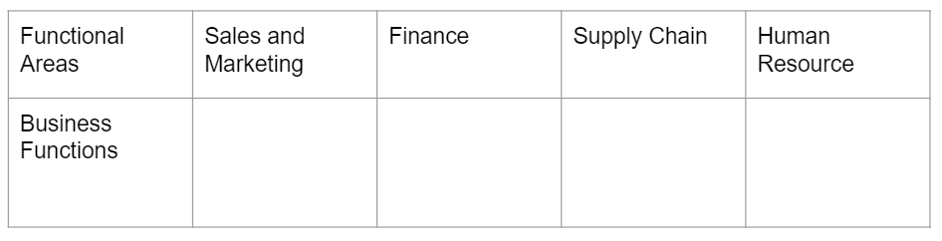

- The Sales Manager for West End Bicycles can set up a Sales team that comprises of staff within the Sales and Marketing Department or staff from the Sales and Marketing and Finance department. This team will be responsible for all the customer orders at West End Bicycles. Which option that you think the Sales Manager would take in setting up the Sales Team

- Describe all the flows of information between Marketing and Sales and Accounting and Finance in West End Bicycles.
SAP
West End Bicycles

Sales order data
Sales order

Sales invoice
Order status
Accounting &
Finance
Marketing
&
Sales

- Design/draw a business process for ordering 1000 bicycles from West Company

